Revision and Activity Log History
1 | 10/2/2024 | Fall 2024 Release (Major Overhaul)
2 | 10/2/2024 | Downloaded from Canvas and renamed per standard with is Semester Year – First Last – DSA-1 (e.g., Fall 2024 – Lance Kerwin – DSA-1.docx; or, pdf
3 | 10/15/2024 | Filled out all the information for DSA 1
4 | 10/18/2024 | I started looking into my analysis and scrubbing data that had unfilled cells.
5 | 10/24/2024 | Listened to announcement (09) and DSA 2 and made changes to timeline and updated file name from DSA 1 to DSA 2
6 | 11/06 | Made some analysis and built some visuals.
7 | 11/20 | File submission date and part 5 completed.

DSA-1 Submission Statement (10/16/2024)
“I have assessed my overall effort and believe I have performed (below | at | above) the expectations set by Lance. Here are some highlights: (then list 3-5 bullets)
I have performed at Lance Kerwins expectation.
- I have followed all instructions given in the DSA inspecting file and down all the things required by him.
- I have done research and found a dataset on Kaggle to help me for this project. I selected a clean data set with the stats for gym membership owners with approx. 1000 rows.
- I have generated questions for the data be used for to answer for this project. The answers to those questions will also be used to formulate a visual for this project.

DSA-2 Submission Statement (11/20/2024)
“I have assessed my overall effort and believe I have performed (below | at | above) the expectations set by Lance. Here are some highlights: (then list 3-5 bullets)
I have performed to Lance Kerwins expectations
- I have prepared my dataset, by scrubbing bad data like blank cells and columns that where not a part of my analysis.
- In the story boarding I provided a complete synopsis of what data I was going to use for the visuals and what story the data was going to tell the user.
- I completed step 5 of putting everything together using MS excel and PowerPoint like you did Lance.
- I think with the free will I was given to make and analyze my own story, I did well. I took on the challenge of finding a dataset in something I was interested in and I came up with great questions to make an analyses that I think couldn’t be used on the large scale to help gym members make impact in their journey.

Grading Philosophy
DSA-1 is worth 80 points and DSA-2 is worth 200 points. When we grade your work, you are competing against your colleagues. We group assessments by Below Expectations, Met Expectations, Above Expectations. Anyone below expectations starts with a 78%, meeting expectations starts with an 85%, and above expectations starts with a 95%. EXCEPTIONAL work may grade above 95%. Points are then deducted or added from this point.
This document has five sections. You will be able to glean expectations in each of these sections. Many of the expectations will be provided each week and over the life of the project (Weeks 6-12) to encourage weekly engagement and to simulate an iterative experience of building a data story. I will coach you along the way and I have outlined the coaching videos for you in the DSA Resources page.
The biggest risk to running a multi-week project in an online class is that I have little visibility into your weekly commitment, which is why I encourage a time log, and in this framework, you have a “Revision History and Log History” which are your opportunity to provide analytics to your work product.
I will honor my NO LATE WORK policy meaning that COMPLETED work includes doing the work, submitting the work on Canvas, and confirming that you uploaded the file that you intend for us to grade. If you attach the wrong file, I’m sorry, there is no remedy for a “wrong file” mistake and the impact is significant to you. You will want to plan for early submission so that if you experience a “Technology Issue” that you can work with the Canvas Help Desk so know their hours. I do not support technology issues.
One other situation that I want to share with you so that I can eliminate this from happening this semester. I will receive emails from students about 24-48 hours before the deadline stating that they are sick. The only way I can even consider working with you in this situation is if you show me significant progress to date. If I give you 21 days to do a task and you come to me in Day 19 stating that you are sick and need an extension, then we actually have a complex problem. You would have to be able to demonstrate that you have completed 19/21 (90%) of the work which is a very tough standard to prove. Please start early and please work in iterations. This methodology will increase your overall quality and position you for an experience that you will be able to leverage in your interviews.

DSA-1: Setup and Configuration

1. Data Visualization Scope and Plan
Evaluation: grading you on your ability to plan and to apply the concepts/frameworks that we’ve learned to date. I would suggest answering the following questions like an essay, or English paper.

What is Business Analytics?
Business Analytics is the process corporations and people use to dissect data. The process uses tools and methods to see patterns and trends to form data driven decisions.

Data Gathering Process

I started my search off by thinking about something I am interested in. That led me to thinking about my favorite sport and hobby which is the gym and fitness training overall. I went over to google and searched up “open data sets for the gym”. After going through what using the analyze data tool in excel which has already answered some of my questions felt like a million data sets, I chose one that met the questions I needed to know. I did some sorting and started to formulate some insights

Confirming Expectations of the DSA by writing about the Evaluation Process

The grading philosophy includes the expectations of Mr. Kerwin and the grade percentages of each of level of work. I will be expected to complete five sections for the DSA project. Lance will not take any late work and will expect the correct file to be uploaded. Also work would be done 48 hours before it is due to ensure technology problems cannot be an excuse. For DSA 1 sections 1-2 should be filled out and the revisions table should also be completed.

Business Question

After reviewing this data, I have a few questions. My first question is based off workout type, what is the total BMI of each is and of those who has the highest. This would tell me which workout type is more common amongst the bigger weighted population and the smaller weighted population. My next question is what the average age of men and women who go to the gym. What workout type burns the most calories. And lastly what is the trend of workout type choice between women and men.

Timeline
Evaluation: grading you on your ability to build a detailed plan and to anticipate what you task you think you need to complete in the future.
The following section will outline your tasks from Weeks 1-12. I would expect you to read through this document and based on your understanding from Week 5 through Week 12, provide a list of activities that you think you need to conduct to complete all five sections of the DSA framework. DSA-1 is a milestone assessing how you completed Sections 1 and 2. DSA-2 is the final work product which includes your content for Sections 3-5. I would recommend reading ahead.

For the Fall of 2024
I’m asking you to go back and time and capture the activities that should have been completed from Week 1 through Week 5. Take credit for what tasks you completed. Those task that you didn’t complete, you should create tasks starting in Week 6 and beyond to catch up.
Note: the DSA is a “Living Document”, and I will be focused on completing Sections 1 and 2 by 10/16/2024. I understand the scope of DSA-2 is Sections 3-5 which is due on 10/16/2024.
The following content is an example outline. I expect you to use this outline and to change the dates that I have in parentheses.
Week 1 Activities Aug 29 – Sep:
Course Overview and Setup; Introduction to Business Analytics / VIGOACRE Summary
Contract Quiz
Week 2 Activities Sep 5 -11:
Read announcement (01) and documented the task list
Communications - Storytelling (ch.7)
EC 01 - Setting up Activity Pack (5 points
Week 3 Activities Sep 12 -18:
The Importance of Context (ch.1)
Focus Data, Information, and Analytics
Week 4 Activities Sep 19 – 25:
Choosing an Effective Visual (ch.2)
Activity 1
Week 5 Activities Sep 25 – Oct 2:
Setting up the Data Science Activity (8-week Individual Project)
DSA 1 Week 1
Week 6 Activities Oct 3 – 9:
Research Datasets (townhall #1)
Activity 2
DSA 1 work on it
Week 7 Activities Oct 10 – 16:
Clutter is the enemy
DSA 1 due
Week 8 Oct 17 – 23:
Focus your audience attention
Mid-term 10/22
Work on DSA 2
Week 9 Oct 24 – 30:
Think like a designer & work on DSA 2 part 3
Week 10 Oct 31-Nov 6:
Dissecting model visuals and pulling it all together
Work on DSA 2 part 4
Activity 4
Week 11 Nov 7 – 13:
DSA preparation Townhall 2
Work on DSA 2 part 5
Week 12 Nov 14-20:
Loose ends and catch up
Submission week of DSA 2
DSA 2
Week 13 Nov 21- 27: Business case
Week 14 Nov 28 -Dec 4:
Exam review
Week 15 Dec 5-11:
Final thoughts and exam
2.Describe your Dataset
Evaluation: grading you on the level of context and content you can provide when evaluating the data types you’ve collected.
In this section, you will be describing the data that you expect to collect. For example, the options outlined in the DSA Resources page has questions. Those questions have answers. The tables below describe the answers in terms of attributes or columns/fields in a spreadsheet.
NOTE: Upon your DSA-1 submission, upload the data you wish to use.

Data Definition

Table 1: Gym members exercise tracking
Populate the table below per the DSA Launch Video. You may need to add more than one table based on the datasets you find.
Attribute / Column Name | Values | Purpose for Collecting / Analyzing Data
Type of Gender | Alphas | Shows me the gender of the person whose data I am analyzing.
Weight and water intake | integers | Used to see how much the person weighs and how much water they drink. Will be used to see weight trends per workout type.
ALL BPMS | numbers | Is the data used to see how intense each workout is without being there.
Session duration and calories burned | numbers | How long the workout is and how effective it is. Used to see how what exercise type burns the most calories in the shortest amount of time.
Weight and height | integers | Used to show the build of the user.
Experience level and frequency | numbers | Shows how confident the user is in working out and how often they go to the gym.
Workout type and fat percentage | Alphas | Shows the different workout methods and the fat percentage of the people using them; in which will be analyzed along with other data to determine which workout method is the best.
BMI | integers | Shows the user body mass index in relation to height and weight.

During your analysis of the data, you may uncover potential data quality issues or consistencies. You should start keeping a list of data quality issues.
Datasets on Kaggle can be found by filtering out certain things. This data set was selected from the “Clean data” option. There have very minimal problems with this dataset beside in some of the cells for weight and height there were values missing. I am assuming since this data set if from a real gym, some people just didn’t want to share that personal data. I have erased all the rows with quality issues, and it came up to 341 rows and only 1 column that got scrubbed.

DSA-2: Data Preparation and Visualization
The DSA-2 scope includes sections 3-5. Similar to the DSA-1 submission, I provide you with an opportunity to self-assess by providing a Submission Statement with your work at the beginning of this document. Here is the point breakdown for the DSA-2 sections:
- Section 3: Preparing your Dataset
- Section 4: Storyboard
- Section 5: Storytelling with Data

3.Preparing your Dataset
Evaluation: grading you on your dataset. Was it structured? Scrubbed for quality? Did your explanation make sense?

When I first got the data set it had a total of 1315 rows, and 15 columns. The columns represent things like weight, height, BMI, max bpm, etc. As far as rows I have deleted it down to 974 because of data quality issues. Many rows had information, for example blank BMI and weight, which I figured was due to some people just not wanting to give the gym that type of information. I just did not want missing information to mess up my analysis, so I kept the rows that had all information filled in. For my project I am using only one data set because this is something I am interested in because I go to gym and feel like a lot of people use different workout methods, but I never know if theirs is more effective over mine. Also, with this project, my past interactions with the Double Albatross helped a lot I learned to highlight data quality issues as I’m inspecting the data and delete it.

4.Storyboard
Evaluation: grading you on your ability to apply concepts that you’ve learned in the course. You will want to consider leveraging any of the models such as descriptive, prescriptive/decision, or predictive.

Graph 1: All exercise levels vs the sum of calories burned for each (Data is from top 10 of each)

I plan to use a vertical bar graph to show how different types of exercise affect the body, with a focus on strength training. After filtering a dataset of the top ten exercises and using Excel to build visuals, I found that strength training is not only effective for building muscle and boosting metabolism but also the most efficient for weight loss, burning more calories than other methods. In contrast, the data shows that HIIT, while popular for fat burning, is less effective for weight loss. The graph will highlight these differences, with strength training outperforming HIIT in calorie burn and overall weight loss impact.

Graph 2: Male vs Female BPM’s and Duration

I plan to use a slope graph to illustrate differences in cardiovascular performance during workouts, highlighting max, average, and resting BPM. This type of graph is ideal for comparing these metrics over time. Based on the data, it appears that women tend to have lower BPM at every level (max, average, and resting), suggesting that they may not push as hard during workouts compared to men. The data also shows that men generally work out for longer durations. This slope graph supports the analysis from the earlier chart, where strength training ranked highest, which aligns with the fact that men, who dominate this form of exercise, lead in cardiovascular intensity as well.

Graph 3: Experience in correlation to frequency Scatter Plot
I chose a scatter plot for this visualization to highlight how gym visits vary based on experience level. The graph shows that those at experience level 1 typically visit the gym 2-3 times per week, while those at level 3 go as often as 4-5 times per week. This indicates a clear correlation between experience level and gym frequency, which helps explain why more experienced gym-goers tend to be in better shape. This graph will also include a liner regression (trendline) to show the trajectory of increased gym frequency with experience.

Graph 4: The Table Visual of the correlation between water intake and boy fat

I chose the table to represent this data because based off the Storytelling book I need a simple but useful data visualization for this comparison. I extracted the top and bottom half of body fat percentages from gym members, and it shows that people who drink less water have a higher body fat. This further proves that water helps with weight loss I a way.

5.Storytelling with Data
Evaluation: were you able to follow directions? Were you able to use MS Excel to create your four graphs? Did your presentation look compelling and professional? Did you take time to “design” how you presented your data? Did your data tell a story? Did you incorporate your four graphs into a SINGLE visual?
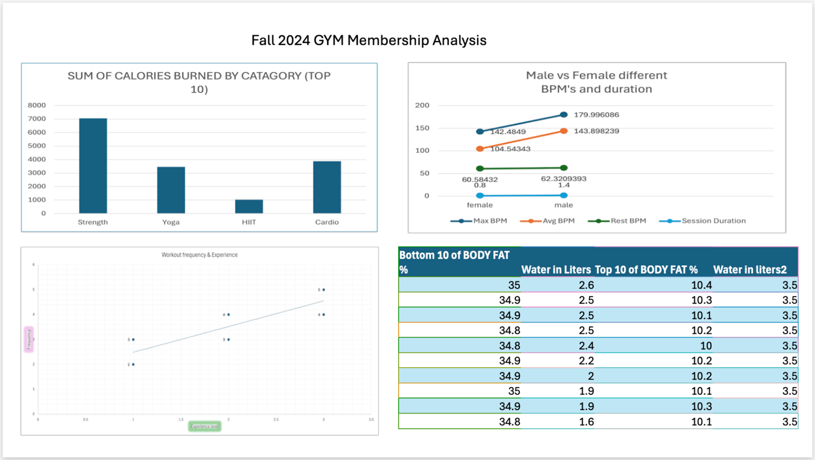
This visual was produced and designed in MS excel and PowerPoint, this visual was made from extracted data of a gym membership database. The data above was selectively chose by me generating thinking points of how I could use data to improve gym knowledge about workout methods.
Provide talking points to support your visualization below:
- Graph 1 in the top left corner is a vertical bar chart showing calories burned by user who do different workout methods. Form the graph it is shown that Strength training is the most effective workout method among all other methods of workouts; followed by cardio, yoga, and lastly HIIT training. The graph is specifically pulled from the top 10 performers of the entire data set.

- Graph 2 in the top right corner is a slope graph which is used for showing data in different time periods. The data points on each line of data symbolize not only the point of data but the gender of the data, boys on the right girl’s ion the left. From the graph it is apparent that boys have higher BPM’s while working out and a longer workout duration which simultaneously means men have a higher workout intensity over women.

- Graph 3 is a scatter plot graph in the lower left corner which shows how experience level affects workout frequency. It can be seen from the graph that the higher the experience level the more times a week a member is likely to go to the gym.

- Graph 4 in the bottom right corner is a simple table graph which shows how water intake directly correlates to a lower fat percentage.

